Data Sync Process

Problem statement
The purpose of the requirements document is to systematically capture requirements for the project and the system “User Data Sync” to be developed. The application should be a Microservices. Both functional and non-functional requirements are captured in this document. It also serves as the input for the project scoping.
About the System
The client would like to develop an independent application Message Bus in order to automate the process of syncing data between users belongs to various vertical.
Scope of the System
The scope of the system is explained through its modules as follows
- Sync Data: We have same Layer belongs to Website A and Website B Both the Websites have their own tech stack. Whenever user edits any of the fields (First Name, Last Name, Admission, Practicing Area, Practice location). This should be synced across both the system using Kafka and message should be serialized using AVRO Schema
- Consider BFF pattern
- Architecture Diagram for the Problem Statement
Use case Diagram

US_01 Kafka Setup
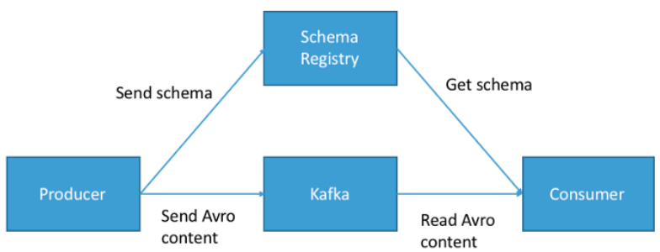

US_02 MicroServices
Auth Server:
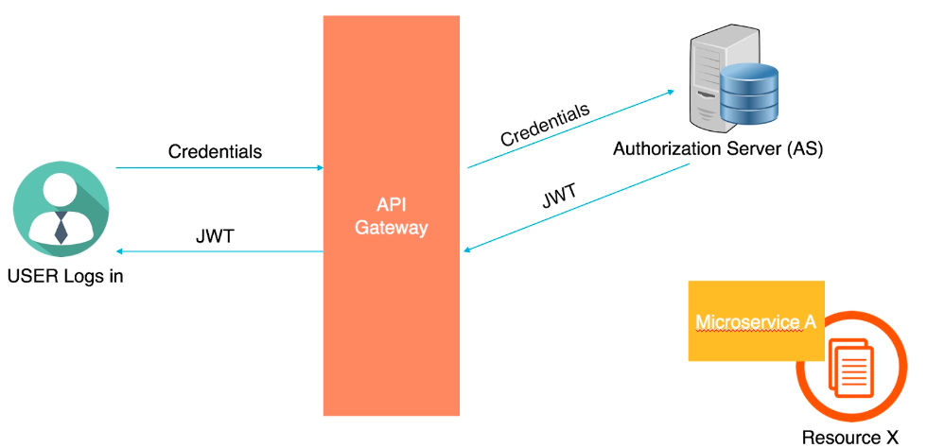
MicroServices:
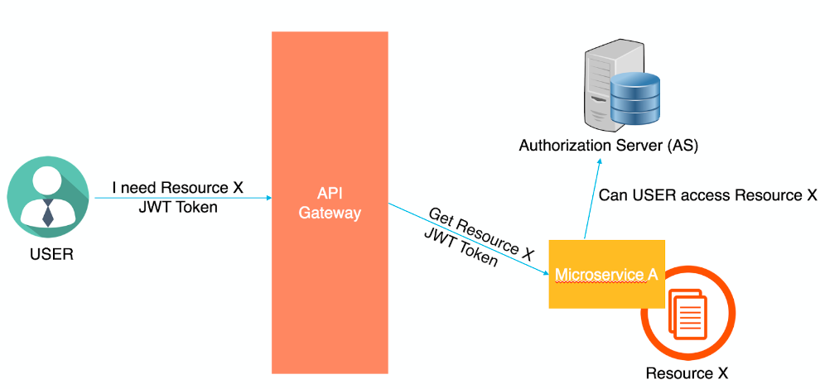

US_03 Website A & B
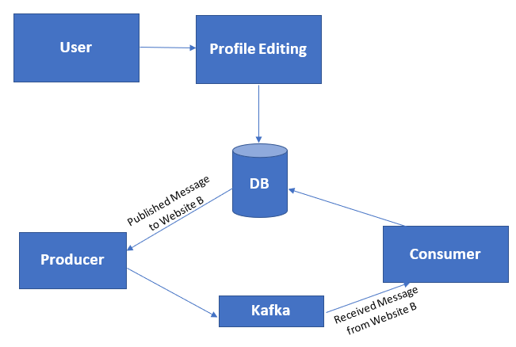
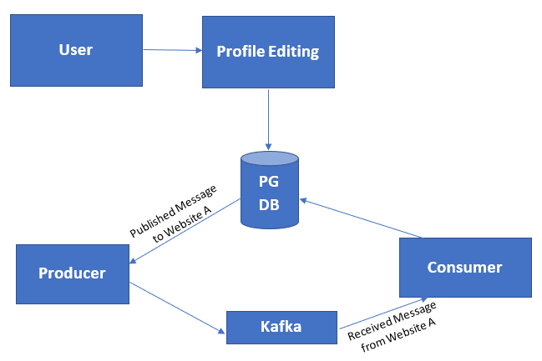

- Use case details
User Story # | User Story Name | User Story
US_01 | Kafka System Configuration | Create a Kafka System to communicate/sync the data between two systems. Each Message should follow the AVRO Schema
US_02 | Microservice | Create list microservices required for a website to authenticate and save profile fields
US_03 | Create Website B & dependent Micro Service  Create Website A & dependent Micro Service | As a User I should be able to edit the Following data Name, Admission, Practicing Area, Practice location  Acceptance Criteria:  User should be Authenticated  Create a microservice to update the Data
- Functional/Non-Functional Requirement of the Problem Statement
US -01 Kafka AVRO
Business Rules & Validations
- Create Kafka system with partitions to process message
- AVRO schema should have proper types
- Validate the message with AVRO Schema
- Each Message should be serialized before processing (Publish/ Consume)

US_01 | Kafka Server Configuration
Description
Create a Kafka Server to process and sync two systems

Input Parameters
Below are the input parameters.
Avro Serialized Message containing payload (First Name, Last Name, Admission, Practicing Area, Practice location)
Business Rules & Validations
- All fields are mandator if present in the message
- All the fields should have proper Avro type

Website A
US_02 | Microservices
Description
Develop the backend application as a microservice architecture
Input Parameters
Below are the input parameters.
First Name, Last Name, Email, Born, Admission, Practicing Area, Practice location, Position
Business Rules & Validations
- All fields are mandatory.
- First Name & Last Name should be minimum 5 characters to maximum 35 characters in length
- Practice Area should be string and 100 characters long.
- Date of admission should be less than current Year and should be after 1950
- Year Born should be 25yrs less than the current year and 21yrs less than year of Admission
- Year Born & Admission should accept only Date field

Member Update
US_03 | Website
Description
Create a UI for Two systems (Website A & Website B)
Input Parameter
- Member should be able to update only his mail id, PAN number, state, address, contact number.
- Email id should be validated.
- PAN number should not contain any special characters.
- When a member has dependents their name, DOB should be prepopulated. DOB of the dependents can be edited.
Business Rules & Validations
- Name should be minimum 5 characters to maximum 35 characters in length
- Few cases you should join First name and Last Name
- Practice Area should be String and 100 characters long.
- Date of admission should be less than current Year and should be after 1950
- Admission should accept only Date field

Service Requirements

US_02 Microservices

Once the user enters the details, they should be sent to the POST method and saved in the db.
Mandatory fields should be validated as mentioned in the rules above and 400 exception response should be sent with the missing field details.
When the details are saved successfully, the service should response 200 ok along with success message.
If there are any exceptions while connecting/saving to DB, the service should throw corresponding error with error status as 500.
Document REST endpoints with OpenAPI or Swagger
Expose all rest Endpoints using a common API Gateway.

US_03 Front End

To retrieve the member/dependent details on entering the name field, a GET method should be implemented to fetch the details.

Once the user enters the details, they should be sent to the PUT method and saved in the db.
Mandatory fields should be validated as mentioned in the rules above and 400 exception response should be sent with the missing field details. When the details are saved successfully, the service should response 200 ok along with success message.
If there are, any exceptions while connecting/saving to DB. The service should throw corresponding error with error status as 500.

Expected Deliverables
The following deliverables are expected as outcomes:
- Application Code base
- Readme document on the complete application
- Setup of the application
- How to run the application
- Any inference
- Screenshot of UI results
- Reports:
- Unit/Functional Test Report

- Milestone
The milestone for the project use is given below
Milestone | Duration (in weeks) | Topic (BFF)
Milestone - 1 |  | Develop the Kafka broker (Mesaging bus) to sync the data.
Milestone -2 |  | Develop the required APIs for the application  Develop all the APIs with NodeJS / PHP.
Milestone -3 |  | Design and develop the UI for the application. Integrate service layer with UI component, Dockerize the application and Push your Docker images to an cloud.

- Skills to develop the project
List the Technology based on your respective technology stack, that will be used to development the project.

Skill Stack | .net – Azure/AWS
Front end | Angular /React  Bootstrap/ CSS  JavaScript/ jQuery  Typescript  Karma/ Cypress/ Jest
Service End | NodeJS/Express JS/PHP  Jest/Supertest/mocha/ Sinon
Database | PostgreSQL & MongoDB / InMemory
AWS/ Azure | AWS code commit  Amazon ECR repository

- Implementation Notes
As per the project requirement modification can be done in the below table.
Milestone -1 | - Implement user-stories using any one of the UI frameworks [Angular/React]  - Implement Forms, databinding, validations  - Use appropriate unit test framework.
Milestone -2 | SpringBoot:  Create .net Microservices to perform SAVE Operation using POST method.  - Use Microservices Architecture  - Follow coding standards  - Follow Standard project structure  - Message input/output format should be in JSON (Read the values from the property/input files, wherever applicable). Input/output format can be designed as per the discretion of the participant  - Database connections and web service URLs should be configurable.  - Use browser / POST Man to invoke APIs  - Run SonarQube for code quality.  - Implement Junit for unit testing.  NodeJS:  - Create a NodeJS project code  - Develop a POST API method  - Use NodeJS/Express project structure.  - Follow coding standards  - Message input/output format should be in JSON (Read the values from the property/input files, wherever applicable). Input/output format can be designed as per the discretion of the participant  - Database connections should be configurable.  - Use browser / POST Man to invoke APIs  - Write test cases and Implement unit testing.
Milestone -3 | - Integrate service layer with UI component.  - Dockerize the application  - Push your Docker images to an Amazon ECR repository

8.0 Evaluation rubrics
Angular | - Associate must have used Angular Components, Modules, Databinding, data validation, CLI commands.  - Associate must have used Forms and Forms validation  - Associate must have used Directives  - Associate must have developed Reusable Components  - Associate must have followed coding standards
REACT | - Associate must have used Component, Databinding, data validation, CLI commands.  - Associate must have used Forms and Forms validation  - Associate must have defined React state  - Associate must have followed coding standards
Microservices | - REST controller  - Follow controller ->service->Dao model  - Entity and Model classes  - Appropriate logging statements  - Exception handling
Docker | - Dockerize the application  - Build docker containers  - Push your Docker images to an Amazon ECR repository with the docker push command
NodeJS/ExpressJS | - NodeJS, Helmet and Express JS should be used in the  - API’s application  - Advantage of using NodeJS, Projections in Mongo Queries over other frameworks.
AWS/Azure | - Code is committed in AWS  - Push your container images to Amazon Elastic Container Registry

